Visit the Library
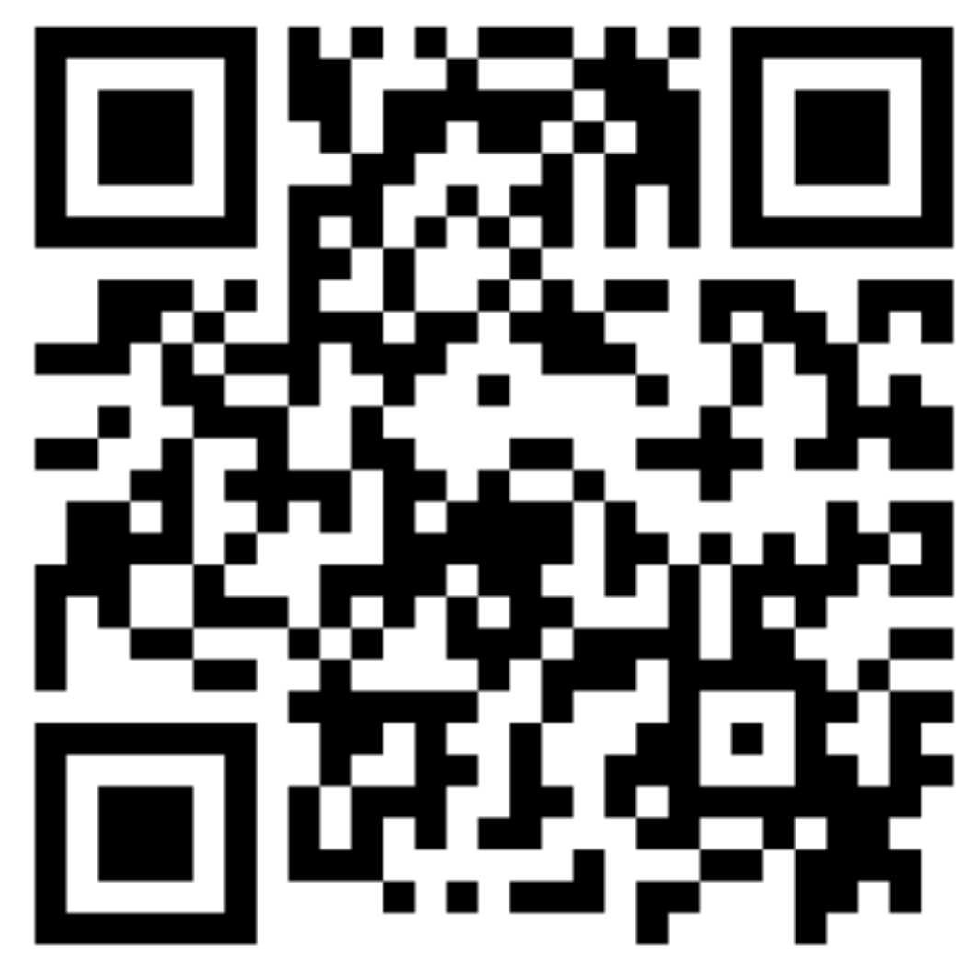
Scan to listen
There are over 330 libraries in Ireland. There are 750,000 people who are members of the library. Over the next few years, the libraries hope to double the number of people who are members.
Last year some major changes were made to the library service. Each and every library in Ireland is now connected to the same computer system which means that a member can request a book from the library in any part of the country and it will be delivered to their local branch within a few days.
It won’t cost you anything to join as membership is free. There are 12 million books available to borrow that suit all tastes.
There is a wide variety of topics to choose from.
To make it easier for you to choose a book the books are split into categories. There are children’s books, teenager books and books for adults.
There are large print books for those with sight difficulties. There are books available on a CD for anyone who is blind or would just like to hear a story read to them.

A member can take out up to 6 books for a period of four weeks at a time.

Activities
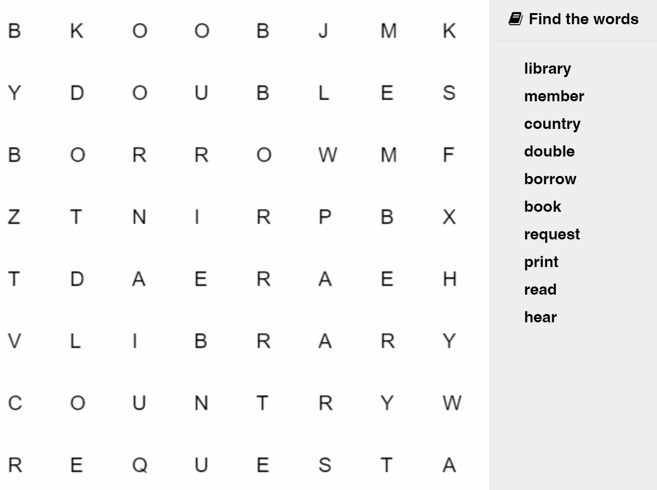

Find out information about your local library and enter it below:
Address: __________________________________________________________
Phone Number: ____________________________________________
Opening Hours: _____________________________________________

