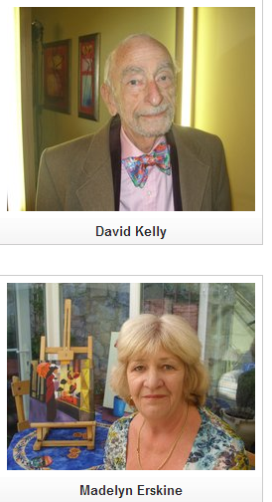
The Spike RTE 1978
In 1978, RTE launched a 10 part drama series which was destined to become front page news. It raised issues about inequality in the Irish education system and in Irish society in general. It also featured the first ever naked Irish woman filmed by and shown on the national broadcasting service.
The series was called The Spike and it was axed by RTE after the fifth episode.
Set in a tough post-primary school in an urban working class area in the late seventies, The Spike was a new departure for RTE Television drama. It was to be a gritty and realistic picture of the Irish education system and flowing from that a wider of picture of Irish society.
The series touched on many social problems linked to class and poverty. Among the issues it dealt with were literacy, domestic violence, republicanism, lack of career opportunities, political hypocrisy and the struggle for control of the education system between Church and State.
As soon as The Spike went on air, the letters pages of the newspapers were full of negative reviews and reactions.
The Spike finally floundered on the rock of Episode 5. This episode dealt with adult evening classes and it featured an art class involving a nude model. Although tastefully shot, the producer's brave decision to show the nude model sounded the death knell for the series. Once actress Madelyn Erskine cast off her clothes, The Spike was doomed.
In the next few days, all hell broke loose. The Spike and RTE were roundly condemned by the press, while RTE was inundated with irate letters and phone calls from angry viewers. County Councils up and down the country passed motions calling for the axing of The Spike, saying it was vulgar and suggestive and a slur on teachers and the education system.
JB Murray, head of the League of Decency and a staunch campaigner against The Spike from the outset, suffered a heart attack while phoning the papers to complain about the nude scene. The Fine Gael spokesman on education, Eddie Collins, sent a telegram to the RTE Director General asking him to cancel the series.
The decision by RTE's Director General, Oliver Maloney, to withdraw The Spike after the fifth episode sparked bitter controversy within RTE.
Even the then Taoiseach, Jack Lynch, became embroiled in the controversy using the occasion of the Jacob's awards to express his support for the decision to take The Spike off the air, despite the fact that he had not seen it.
Ironically the most explosive and controversial material was still to come and would have caused further outrage had they been seen. However, these episodes have never been aired.

Questions
- How many episodes were shown?
________________________________________
- What issues did it raise?
_______________________________________________________________________________________________________________________________________________________________________________________________________________________
__________________________________________________________________________________________________________________________________________________________________________________________________________________________________________________________________
- Why were people unhappy with the programme?
____________________________________________________________________________________________________________________________________________________________________________
- In your opinion how would people react now to such a programme?
____________________________________________________________________________________________________________________________________________________________________________________________________________________________________________________________________________________________________________________________________________________________________________________________________________________________________________________________________________________________________________________________________
- Look up the following words from the piece, write out their meaning and put them into a sentence.
- Inequality
- Urban
- Departure
- Realistic
- Condemned

