Save our beaches
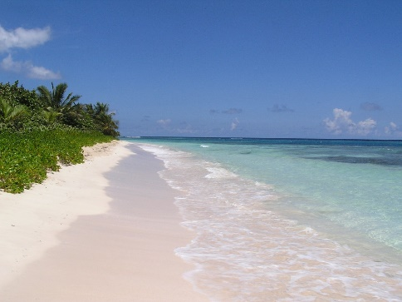
Changes in the earth’s climate could mean that the earth could lose half of its beaches in the future.
If the climate continues to change the world could be a very different place in 80 years’ time. We will have just half the beaches we have now.
If this happens then some very famous beaches in Australia and Brazil could disappear.
The change in climate means that the sea levels are rising and also there is more coastal erosion.
People living along the coast will have to move inland or to higher ground.
Australia is the country which would be most affected.
We need to change the way we live and do things like drive electric cars and take less foreign holidays.

Questions

- Changes in the earth’s climate could mean that the earth could lose how much of its beaches?
__________________________________________________
- What 2 countries could lose beaches?
_________________________________________________
_________________________________________________

- What 2 things happen to beaches.

- Coastal erosion.

- Land sinks.

- Sea level rises.

- Rivers stop flowing.

- Which country would be most affected?
_____________________________________________________________________________

In your own words what do we need to do to avoid climate change?
______________________________________________________________________________________________________________________________________________________________________________________________________________________________________________________________________________________________________________________________________________________________________________________________________________________________________________________________________________________________________________________________________________________________________________________________

