Really unlucky people!
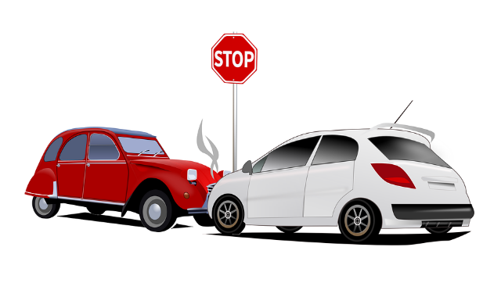

A gust of wind blew a 45-year-old Italian man’s car into a river near Naples, Italy in 1983. He managed to break out a window, climb out, and swim to shore -- where a tree blew over and killed him.
Mike Stewart, 31, of Dallas was filming a public service movie in 1983 on "The Dangers of Low-Level Bridges" when the truck he was standing on passed under a low-level bridge -- killing him.
Walter Hallas, a 26-year-old store clerk in Leeds, England was so afraid of dentists that in 1979 he asked a fellow worker to try to cure his toothache by punching him in the jaw. The punch caused Hallas to fall down, hitting his head, and he died of a fractured skull.
The owner of a factory in the USA narrowly escaped death when a 1983 blast flattened his factory except for one wall. After treatment in hospital, he returned to the scene to search for his files. The remaining wall then collapsed on him, killing him instantly.
In 1983, a Mrs. Carson of New York. was laid out in her coffin, presumed dead of heart disease. As mourners watched, she suddenly sat up. Her daughter dropped dead of fright.
Surprised while burgling a house in Antwerp, Belgium, a thief fled out the back door, climbed over a nine-foot wall, dropped down, and found himself in the city prison.
In 1976, a 22-year-old Irishman, Bob Finnegan, was crossing the busy Falls Road in Belfast, when he was struck by a taxi and flung over its roof.
The taxi drove away and as Finnegan lay stunned in the road, another car ran into him, rolling him into the gutter. It too drove on.
As a group of people gathered to examine the man, a delivery van ploughed through the crowd, leaving in its wake 3 injured people, and an even more battered Bob Finnegan.
When a fourth vehicle came along, the crowd scattered and only one person was hit -- Bob Finnegan.
In the space of two minutes, Finnegan suffered fractured skull, broken pelvis, broken leg, and other assorted injuries. Hospital officials said he would recover.
Have you ever been unlucky? Write about it.
______________________________________________________________________________________________________________________________________________________________________________________________________________________________________________________________________________________________________________________________________________________________________________________________________________________________________________________________________________________________________________________________________________________________________________________________________________________________________________________________________________________________________________________________________________________________________________________________________________________________________________________________________________________________________________________________________________________________________________________________________________________________________________________________________________________________________________________________________________________________________________________________________________________________________________________________________________________________________________________________________________________________________________________________________________________________________________________________________________________________________________________________________________________________________________________________________________________________________________________________________________________________________________________________________________________________

