Pink supermoon seen around the world

People have enjoyed a pink supermoon in the night skies around the world.

The full moon was around 40,000 km closer to Earth than usual.
A supermoon is a full moon where the moon is just a little bit closer to Earth than usual, so it looks a little bit bigger and a little bit brighter.
It’s about 10% closer and 20% bigger in area and brightness.
A supermoon happens when the moon reaches the closest point to Earth in its 27-day orbit and it happens to be full, which occurs approximately once a year.
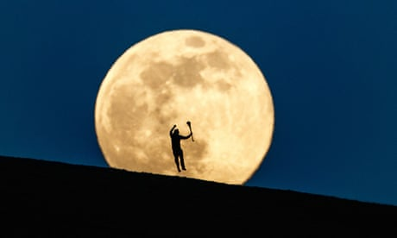

Exercise
How many km closer to earth is the pink moon?
_______________________________________________________________________________
It’s about ____% closer and ____% bigger in area and brightness.
How many days does it take the moon to orbit the earth?
___________________________________________________________________
How often does a full moon happen?
_______________________________________________________________________________
