Parkrun

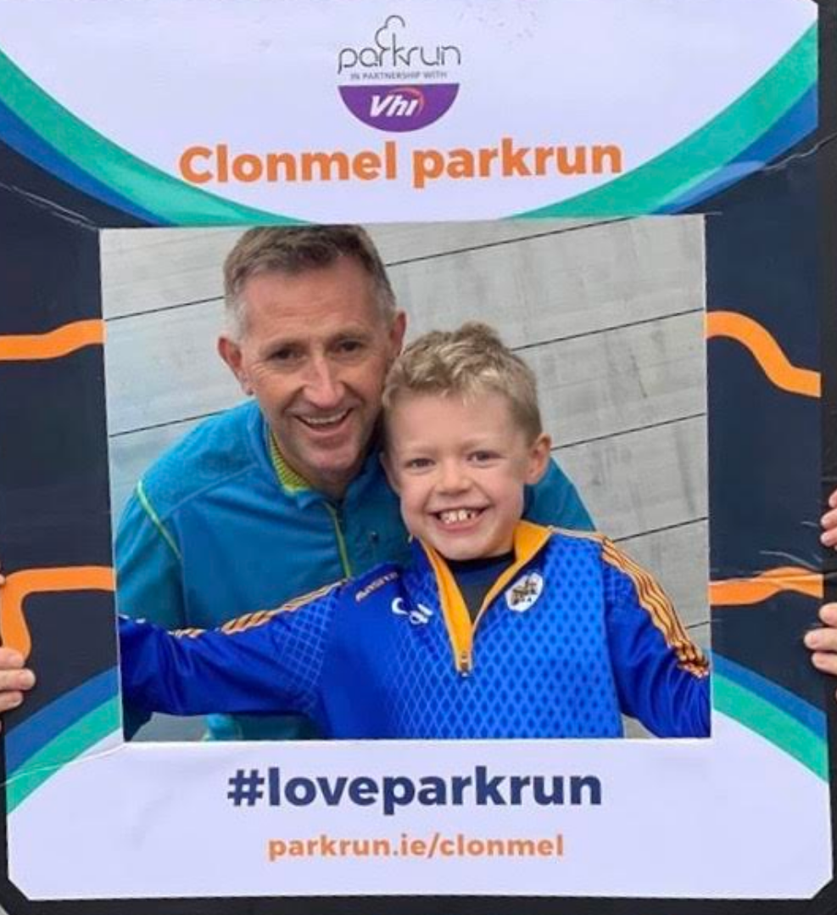 Scan to listen
Parkrun started back in 2004 when 13 runners got together on a blustery day in Bushy Park, Teddington, UK. It’s now an international family of over 5 million park runners (and growing).
Parkruns are free, weekly, community events all around the world.
Saturday morning events are 5k and take place in parks and open spaces. On Sunday mornings, there are 2k junior parkruns for children aged four to 14.
parkrun is a positive, welcoming and inclusive experience where there is no time limit and no one finishes last. Everyone is welcome to come along, whether you walk, jog, run, volunteer or spectate.
Where ever you go if it’s a weekend away or a foreign holiday you’ll probably find a Parkrun nearby!
The format of parkrun is simple: register once, print your barcode, then turn up and take part wherever you want, whenever you want.

Activities below:
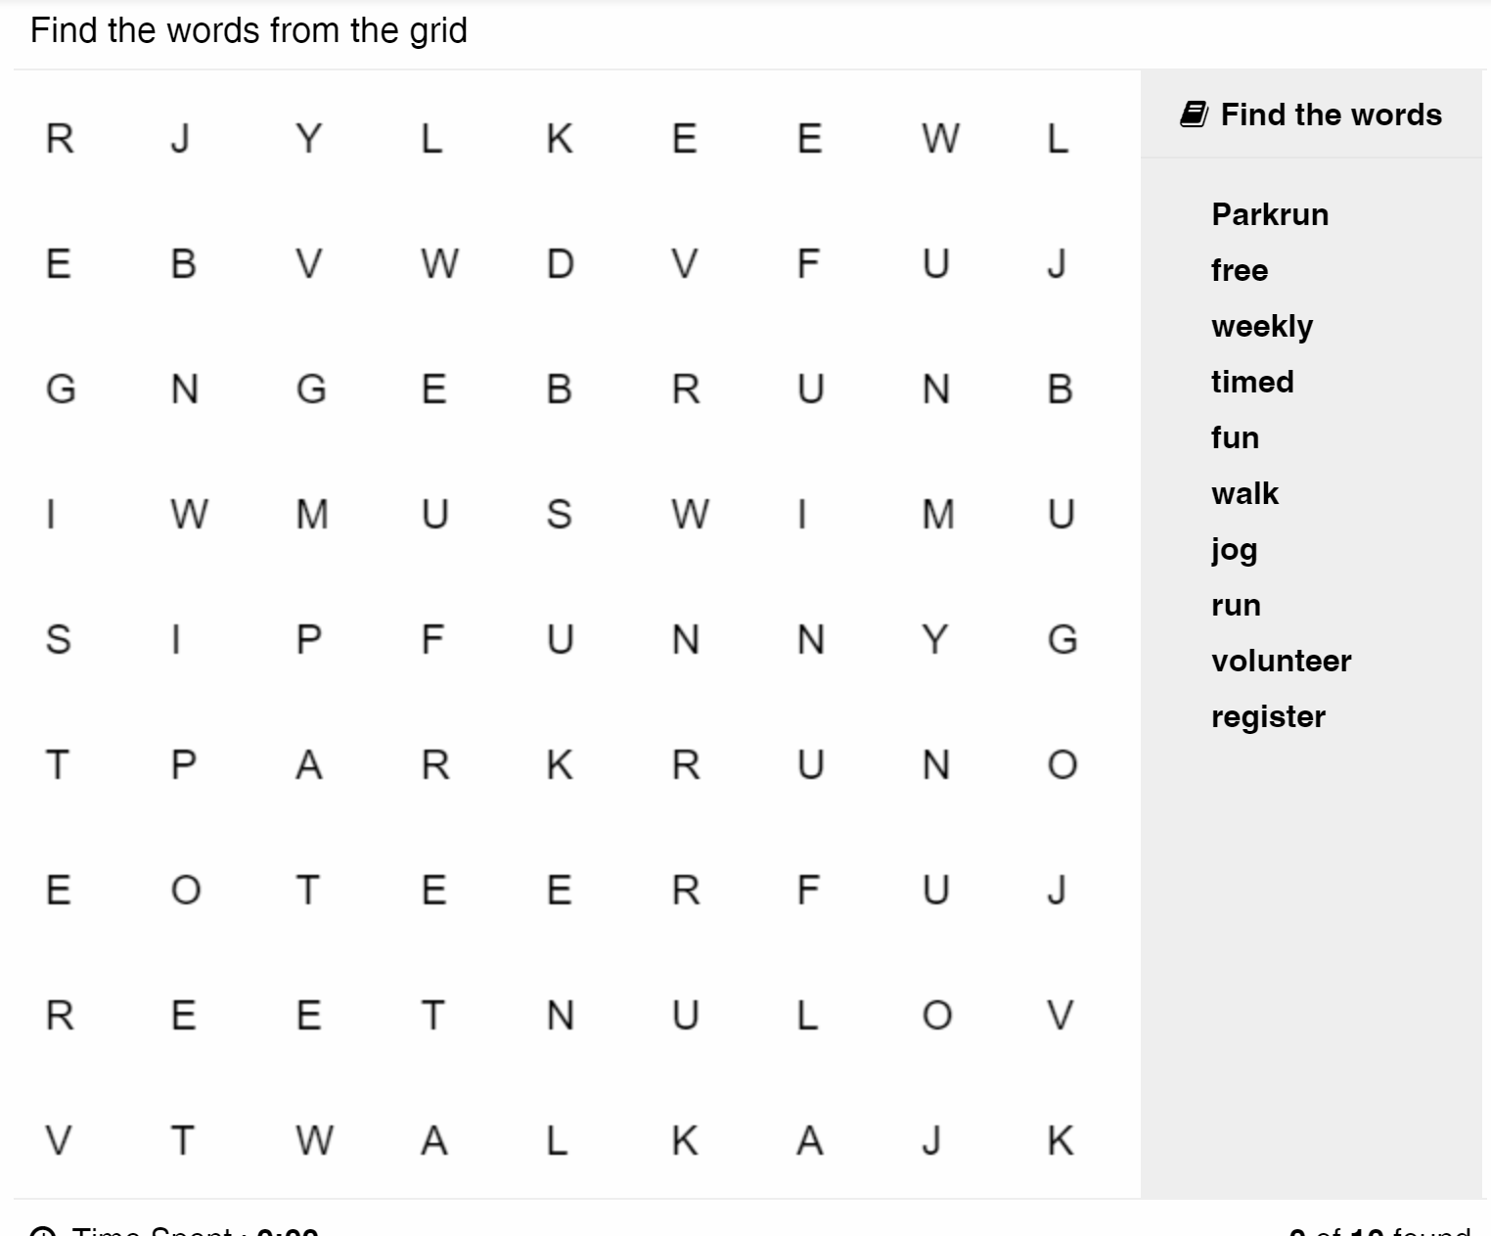
Find your local Parkrun: Go to www. https://www.parkrun.ie/
Circle your nearest Parkrun
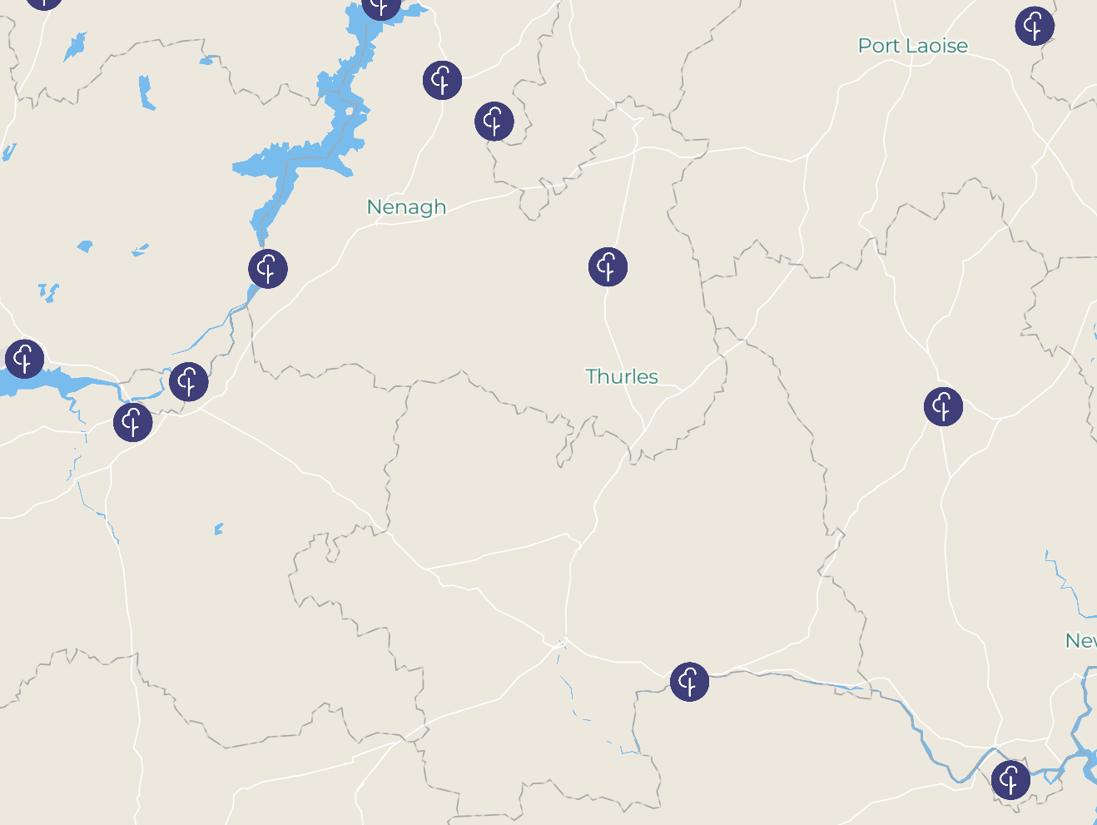
Vicarstown
Knockancree Woods
Borrisokane
Clarisford
Limerick
Mungret
Templemore
Kilkenny
Waterford
Clonmel
How to Register
Go to www.parkrun.ie
Go to
Then
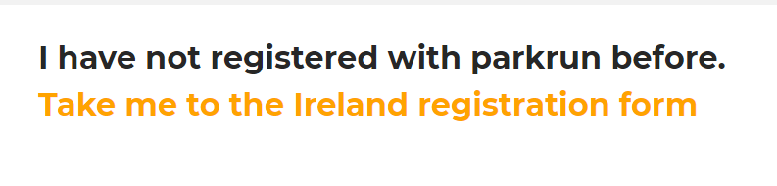
The form to be filled out:
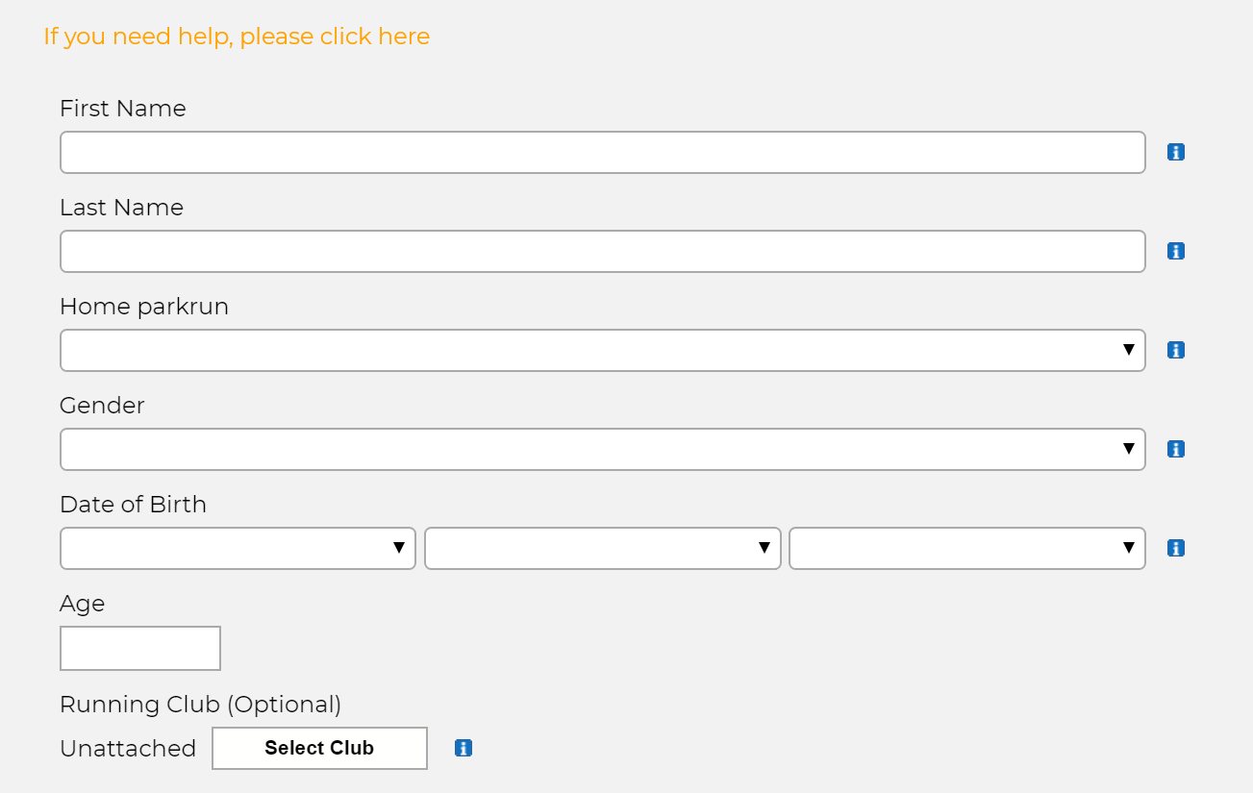
Continued below
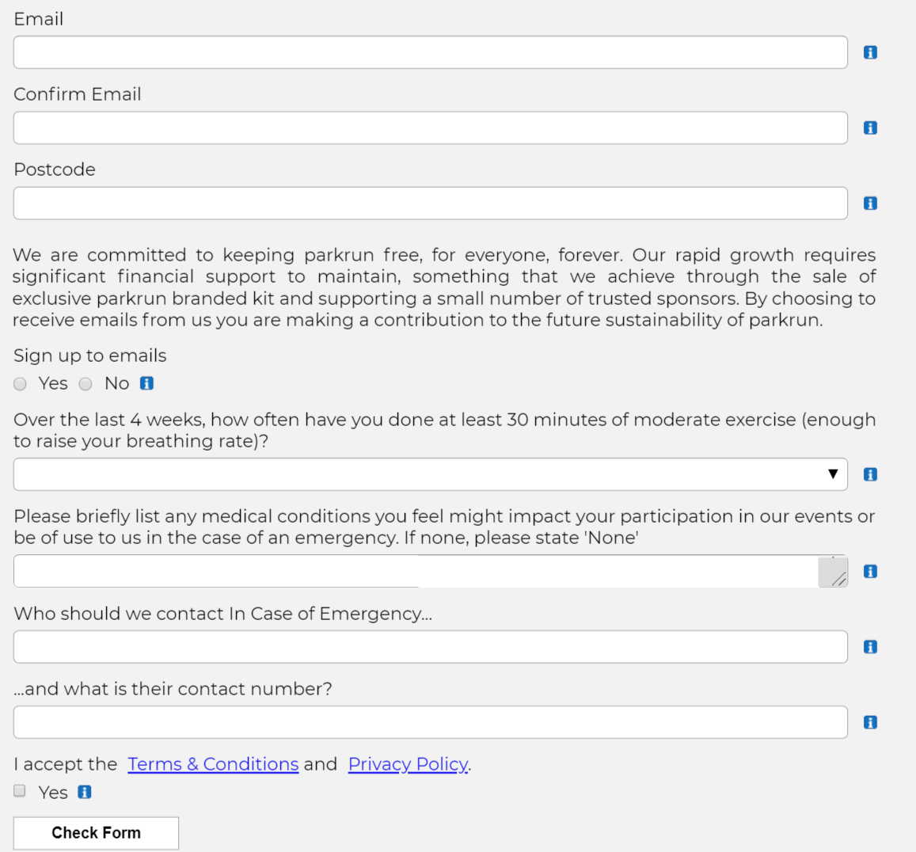
After Registering
You will get a barcode- that’s all you need to take part.Turn up on Saturday morning with your barcode- run, walk or jog.After you finish you will be handed a number- that number together with your barcode will be scanned.
And that’s it. You’re done!!
Later that Saturday you will get an email with your time and position.

