Google self-driving cars hit the city
By Alexei Oreskovic

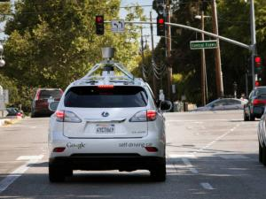
Google has begun testing its self-driving cars on city streets, a crucial new phase in its quest to eventually make the technology a standard feature in cars.
After several years of testing self-driving cars on freeways, where driving conditions are more predictable, Google in the past year shifted its focus to City Street driving, the company said in a post on its official blog on Monday.
Google said it has driven thousands of miles on the streets of Mountain View, California, a small suburban community where the company maintains its headquarters south of San Francisco. Google's driverless cars rely on video cameras, radar sensors, lasers and a database of information collected from manually driven cars to help navigation, according to the company.
“A mile of city driving is much more complex than a mile of freeway driving, with hundreds of different objects moving according to different rules of the road in a small area,” wrote Chris Urmson, the director of Google's self-driving car project in the blog post on Monday.
“We've improved our software so it can detect hundreds of distinct objects - pedestrians, buses, a stop sign held up by a crossing guard, or a cyclist making gestures that indicate a possible turn,” Urmson said.
Google is one of several companies, including carmakers like Nissan, Audi and Toyota, that are testing self-driving car technology. Both Nissan and Mercedes-Benz hope to start selling self-driving cars by 2020.Google's test cars have logged more than 1.1 million kilometres in self-driving mode since 2009. Google said its cars have not caused any accidents while operating in self-drive mode.
Google said it still has many “problems to solve,” including teaching the car to drive more streets in Mountain View, before testing on the streets of another town.
Reuters
Questions
- What company has begun testing its self-driving cars on city streets?
_______________________________________________________
- Where were the cars first tested?
______________________________________________________
- What do the cars rely on to aid navigation?
______________________________________________________________________________________________________________________________________________________
- Would you trust a driverless car? give reasons for your answer
____________________________________________________________________________________________________________________________________________________________________________________________________________________________________________________________________________________________________________________________________________________________________________________________________________________________________________________________________________________________________________________________________________________________________________________________________________________________________________________________________________________________________________________________________________________________________________________________________________________________________________________________________________________________________________________________________
Write the meaning of the following words from the story
- Crucial.
- Phase.
- Quest.
- Conditions.
- Blog.
- Sensors.
- Navigation.
- Manually.
- Gesture
- Indicate.

