Citizens Information
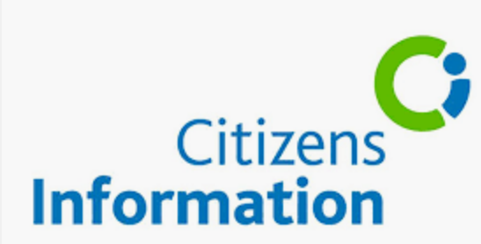 Listen
Citizens Information Services (CISs) provide a face-to-face information service to the public. Through trained staff, the Citizens Information Services provide free, impartial and confidential information, advice and advocacy services to the public. Citizens Information provide information to the public in the following areas:
- Social Welfare
- Employment
- Family and relationships
- Transport
- Justice
- Death and bereavement
- Housing
- Education and training
- Money and Tax
- Consumer affairs
Citizens Information has 260 offices around the country. You do not need an appointment to attend you can just turn up during open times to get advice on a broad range of services and rights. The service is independent and totally impartial.
Citizens Information also gives advice on consumer rights on our consumer helpline, support witnesses in courts through the Witness Service and give pension guidance to people aged over 50.
You can contact CIS by phone from 9am to 5pm, Monday to Friday, on 0761 07 4000.
Your local services are located here:
Clonmel CIC
Market Place, Clonmel
Phone: 0761 07 6460
Nenagh CIC
43 Pearse Street, Nenagh
Phone: 0761 07 6470
Roscrea CIC
Rosemary Street, Roscrea
Phone: 0761 07 6480
Thurles CIC
2nd Floor, Mall House (Over Ely's Centra), Slievenamon Road, Thurles
Phone: 0761 07 6510
Tipperary CIC
Community Centre, St. Michael Street, Tipperary
Phone: 0761 07 6540
