The UK has confirmed plans for an app that will warn users if they have recently been in close contact with someone suspected to be infected with the coronavirus.
The health secretary Matt Hancock announced the move at the government's daily pandemic press briefing.
He said the NHS was "working closely with the world's leading tech companies" on the scheme.
At present, the idea is that people who have self-diagnosed as having coronavirus will be able to declare their status in the app.
The software will then send a yellow alert to any other users who they have recently been close to for an extended period of time.
If a medical test confirms that the original user is indeed infected, then a stronger warning - a red alert - will be sent instead, signalling that the other users should go into quarantine.
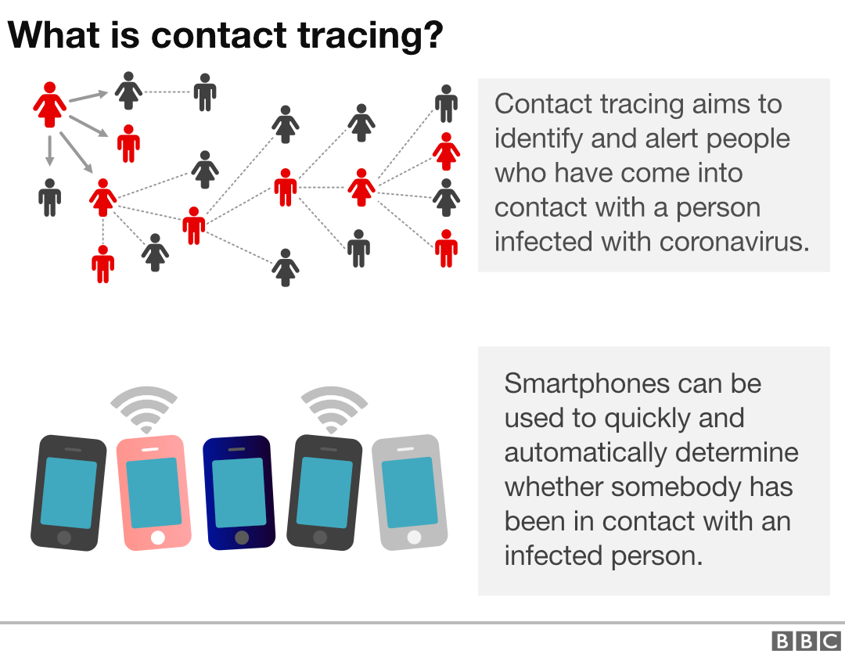

How does this work?
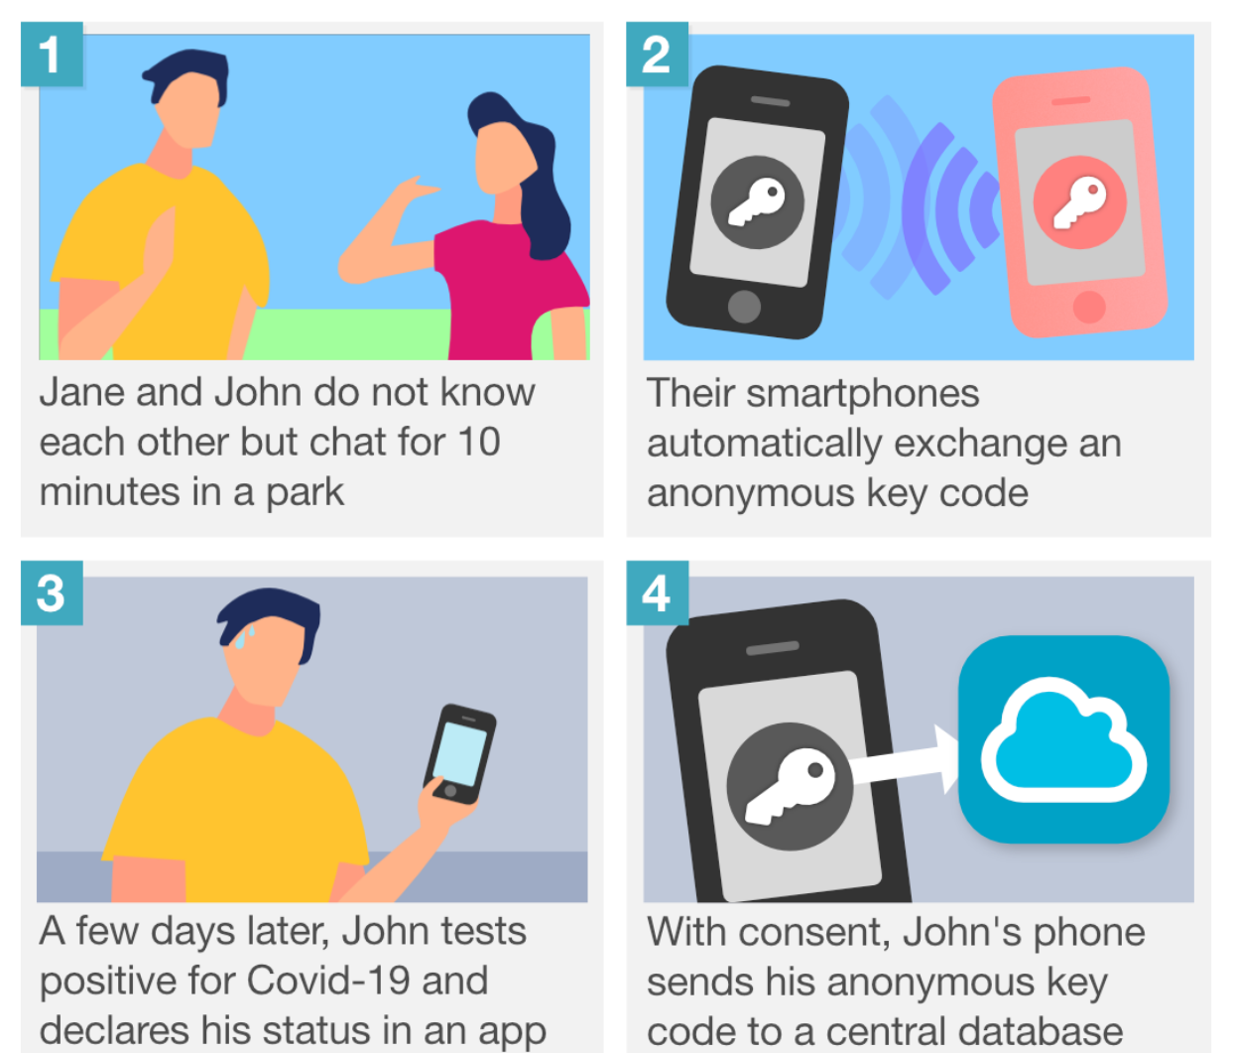
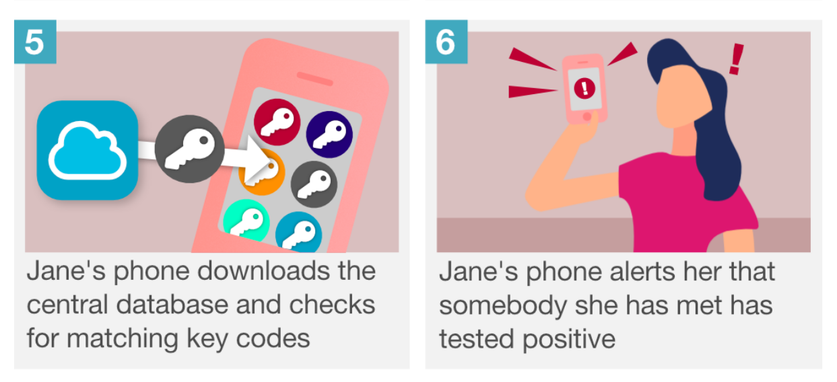

Activities
Read https://www.bbc.com/news/technology-52263244
Using the website https://www.howmanysyllables.com/words/support look up the following words
 | How many syllables | Divide into syllables
extended | 3 | Ex-ten-ded
Confirmed
Suspected
Infected
Secretary
Diagnosed

