The Hindenburg Disaster: Some Surprising Facts
By Christopher Klein
On May 6, 1937, the German airship Hindenburg burst into flames while attempting to land at Lakehurst, New Jersey. In little more than 30 seconds, the largest object ever to soar through the air was burned and the era of commercial airship travel was dead.
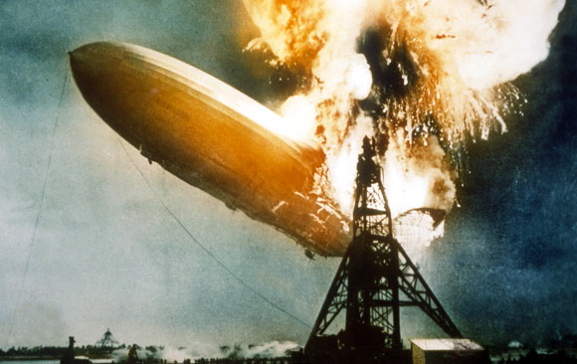

1. Survivors of the Hindenburg disaster far outnumbered the victims.
Anyone who has seen the graphic newsreel video of the Hindenburg falling to earth in flames may be amazed to know that of the 97 passengers and crew on board, 62 survived. The disaster’s 36 deaths included 13 passengers, 22 crew members and one worker on the ground. Many survivors jumped out of the zeppelin’s windows and ran away as fast as they could.
2. The Hindenburg disaster wasn’t history’s deadliest airship accident.
The Hindenburg disaster is the most famous airship accident in history. However, the deadliest incident occurred when the helium-filled USS Akron, a U.S. Navy airship, crashed off the coast of New Jersey in a severe storm on April 4, 1933. Seventy-three men were killed, and only three survived. The 1930 crash of the British military airship R101, which claimed 48 lives, was also deadlier.
3. U.S. law prevented the Hindenburg from using helium instead of hydrogen, which is more flammable.
After the crash of the hydrogen-filled R101, in which most of the crew died in the subsequent fire rather than the impact itself, Hindenburg designer Hugo Eckener sought to use helium, a less flammable lifting gas. However, the United States, which had a monopoly on the world supply of helium and feared that other countries might use the gas for military purposes, banned its export. After the Hindenburg disaster, American public opinion favoured the export of helium to Germany for its next great zeppelin, the LZ 130, and the law was amended to allow helium export for non-military use
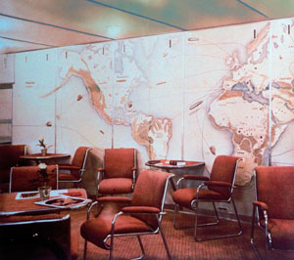
Lounge aboard the Hindenburg. (Credit: Time Life Pictures/Mansell/Getty Images)
4. The Hindenburg had a smokers’ lounge.
Despite being filled with highly combustible hydrogen gas, the Hindenburg featured a smoking room. Passengers were unable to bring matches and personal lighters aboard the zeppelin, but they could buy cigarettes and Cuban cigars on board and light up in a room sealed to prevent any hydrogen from entering. A steward admitted passengers and crew through a double-door airlock into the smokers’ lounge, which had a single electric lighter, and made sure no one left with a lit cigarette or pipe.
5. A specially designed lightweight piano was made for the Hindenburg.
The Hindenburg’s owners, seeking to outfit their airborne luxury liner, asked a piano making firm to build a special lightweight baby grand piano to meet the airship’s strict weight standards. The piano, which was made mostly of alloy and covered in yellow pigskin, weighed less than 400 pounds. It was only used during the Hindenburg’s first flying season, so it wasn’t aboard the ill-fated voyage.
6. Dozens Of letters carried aboard the Hindenburg were delivered.
Zeppelins pioneered airmail service across the Atlantic, and the Hindenburg carried about 17,000 pieces of correspondence on its final voyage. Amazingly, 176 pieces stored in a protective container survived the crash and were delivered four days after the disaster. The pieces, charred but still readable, are among the world’s most valuable artefacts.
7. Goebbels wanted to name the Hindenburg after Adolf Hitler.
The designer of the Hindenburg named the airship after the late German president Paul von Hindenburg and refused Goebbels’ request to name it after Hitler. Hitler, never a lover of the great airships in the first place, was glad that the zeppelin that crashed in a fireball didn’t bear his name.
Questions
- What date did the disaster take place?_________________
- Where did the disaster take place? ____________________
- How many people were on board? ____________________
- How many people survived? _________________________
- How many passengers died? _________________________
- How many crewmen died? ___________________________
- In what year was the deadliest crash? __________________
- What type of gas can be used instead of Helium? _________
- What could the passengers buy in the smoking lounge?
_________________________________________________
- What was the piano covered in?___________________
- Who was the ship named after? _____________
_____________________________________________

