Smartphone 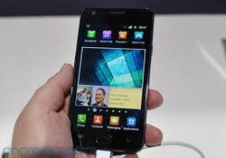
A smartphone is a mobile phone that can do more than other phones.
They are seen as a computer but are small enough to fit in someones hand.
Today, most smartphones are able to run more than one program at the same time which helps the user complete tasks quicker and easier.
Users are also able to get more programs from the manufacturer, such as the Apple App Store, which can help them complete special tasks.
Programs on smartphones are called apps.

Exercises

Fill the gap:
A smartphone is a mobilephone that can do_________ than other phones.
They are seen as a _______________but are small enough to ___ in someone’s hand.
Today, most smart phones are able to run ________ than one program at the ______ time which helps the user complete ___________quicker and easier.
Users are also able to get more programs from the _____________, such as the Apple App Store, which can help them complete special tasks.
Programs on smartphones are called apps.

Look up the following words
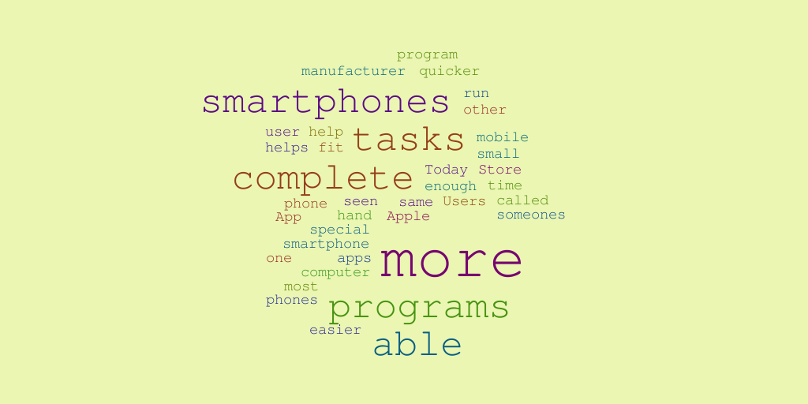
Meaning
Program
Manufacturer
Quicker
Run
Other
User
Fit
Tasks
Mobile
Small
Today
Store
Enough
Able

