Lena Rice
The only Irish woman to win Wimbledon

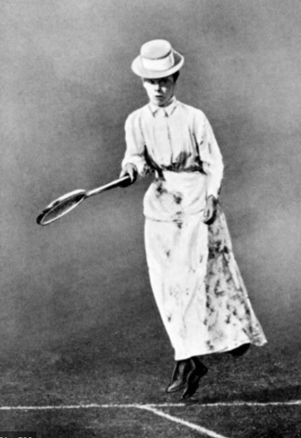
Helena Rice, more commonly referred to as Lena is not a name you may be too familiar with. Born in New Inn, Co. Tipperary in 1866 she was one of 8 siblings and second youngest daughter to Spring and Anna Rice. But more than that, she is the only Irishwoman to have won Wimbledon.
Before she played at Wimbledon and she competed in a mere handful of tournaments. She learned to play at her home, Marlhill, a Georgian mansion which held many tennis parties throughout the 1880s. Both Lena and her sister Annie were keen tennis players and were both members of the Cahir lawn tennis club which at that time had two of the best Lawn courts in Ireland. Over time Lena developed a very powerful forehand serve and forehand drive.
Lena’s first tournament was the Irish Championship held in Fitzwilliam Square, Dublin in 1889. She went on to secure a win in the mixed doubles with fellow player, Willoughby Hamilton. In June that same year both Lena and her sister Annie played at the Lansdowne tournament in Dublin and a just over a week later both headed to England to compete in the Championship at Wimbledon.
At the Wimbledon Tournament of 1889, Lena was narrowly beaten by her opponent, Blanche Hillyard- a woman who went on to win 6 Wimbledon titles but who always said that her match against Lena in 1889 was ‘her most memorable and exciting’.
In 1890 Lena was back on the court and went to compete in the Irish Championships once again. Unfortunately, it was not Lena’s time and she was beaten in the last match by Miss Louise Martin. Even so she continued on to the Lansdowne tournament, steadily improved and won the overall ladies singles title.
Once again Lena was heading back to England to compete in the Wimbledon tournament. She played well and secured her place in the final against Miss Jacks. On July 4th 1890 Lena Rice walked onto the Court wearing an ankle length floral skirt, a blouse which was tight at the waist, brown leather shoes, a black tie and a straw hat. This was the common uniform for players at that time.
After a match which was described as one where Lena’s skill and confidence grew steadily throughout, she secured the win. She was crowned the 1890 Ladies Singles champion! Not only did she win the Challenge trophy, but also the first prize which was 20 Guineas – a sum which Lena used to purchase an emerald and diamond ring.
The 1890 tournament was a great day for Ireland all round. The men’s single title went to Lena’s 1889 doubles partner, Willoughby Hamilton, the first Irish man to win a singles title at Wimbledon. The doubles was also won by two Irish men that year, Joshua Pim and Frank Stoker.
Sadly, what was proving to be a very promising tennis career was cut short as there is no record of Lena ever playing tennis after her Wimbledon win.
It can only be speculated that the reason was that she was needed at home. Lena’s father died in 1868 at aged 41 when she was just two years old, her mother then had to raise all 8 children by herself while running a household. Subsequently her mother had become ill and passed away in 1891 more than likely preventing Lena from defending her title that year.
Wimbledon historians have claimed that if Lena had continued to play, she would have been a dangerous rival to the leading tennis players of the day.
In 1907, Lena Rice died of TB on her 41st birthday, the same age her father was when he passed away.
Questions
What year was Lena born?
_____________________________________________________________________
How many siblings did she have?
_____________________________________________________________________
What was the name of the sister who Lena played tennis with?
_____________________________________________________________________
What club were they members of?
_____________________________________________________________________
Where did Lena play in her first tournament?
_____________________________________________________________________
Who did she win the mixed doubles with?
_____________________________________________________________________
What year did Lena win Wimbledon?
_____________________________________________________________________
How much did she get for winning?
_____________________________________________________________________
Writing
Write about your favourite sport and why you like it. Who is your favourite Irish sports person and why?

Look up the meaning of the following words from the story
Sibling
________________________________________________________________________________
Keen
________________________________________________________________________________
Secure
________________________________________________________________________
Opponent
________________________________________________________________________
Speculate
________________________________________________________________________
Subsequently
________________________________________________________________________

