Jaws Scene- Great White
This scene takes place between Chief Martin Brody, the Mayor Larry Vaughn and Matt Hooper who is an expert on sharks. Brody and Hooper are trying to persuade Vaughn to close the beaches in order to prevent more shark attacks.
The mayor however has a different view.
Watch out for the following in the script and the clip.
1. Body language – Use of arms, hands, stance and facial expressions.
2. The way the discussion has various tones and changes from debate to argument.
3. Who comes across as a more reasonable character?
Brody, Vaughn or Hooper?
To watch see: Youtube

JAWS (1975) Scene: "It's a Great White"/'Eating Machine.'
https://www.youtube.com/watch?v=fGoekw7e-3U
Read the script and watch the scene a few times. Then have a go at answering some of the questions.

Script
Chief Martin Brody:
This is a Great White Larry, a big one! And any shark expert in the world will tell you it's a killer! It's a man-eater!
Hooper:
Look the situation, is that apparently a Great White shark has staked a claim in the waters off Amity Island. And he's going to continue to feed here as long as there is food in the water.
Chief Martin Brody:
And there's no limit to what he's gonna do! I mean we've already had three incidents, two people killed inside of a week. And it's gonna happen again, it happened before! The Jersey beach!
Hooper:
1916. There were--
Chief Martin Brody:
1916! Five people chewed up on the surf!
Hooper: In one week!
Chief Martin Brody: Tell him, tell him about the swimmers!
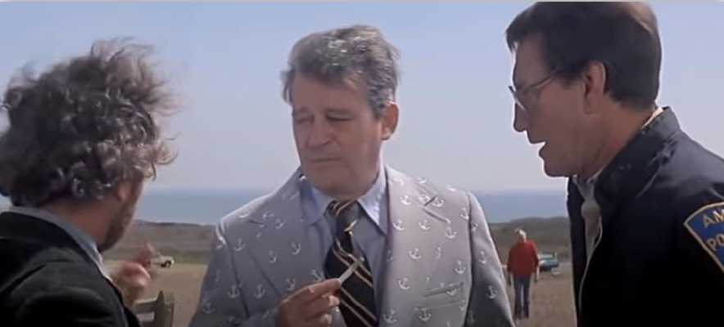

Hooper: A shark is attracted to the exact kind of splashing and activity that occurs whenever human beings go in swimming. You cannot avoid it.
Chief Martin Brody:
If you open the beaches on the fourth of July, it's like ringing the dinner bell for Christ's sakes!
Hooper:
Look Mr. Vaughn. Mr. Vaughn. I pulled a tooth the size of a shot glass out of the wrecked hull of a boat out there and it was the tooth of a Great White.
Chief Martin Brody:
It was Ben Gardner's boat; it was all chewed up. I helped tow it in, you sh-- you should have seen him!
Vaughn:
Where, where is that tooth. Did you see it Brody?
Chief Martin Brody:
No, I didn't see it, he, he dropped it. We had a little accident on the way in.
Hooper:
I had an accident.
Vaughn:
And what did you say the name of this shark is?
Hooper:
It's a Carcharodon Carcharias. It's a Great White!

Vaughn:
But you, you don't have the tooth. Look we depend on the summer people here for our very lives.
Hooper:
You are not going to have a summer unless you deal with this problem!
Vaughn:
And if you close those beaches, we're finished!
Chief Martin Brody:
We're not only gonna have to close the beach, we're gonna have to hire somebody to kill the shark! I mean, we're gonna have to tell the coast guard. We're gonna have to get shark repellent!
Hooper:
Mr. you have to contract a shark research panel.
Chief Martin Brody:
We're gonna have to put extra deputies on because there ain't nothing in the world that's gonna come in here! We've gotta spend money to save what we've got!
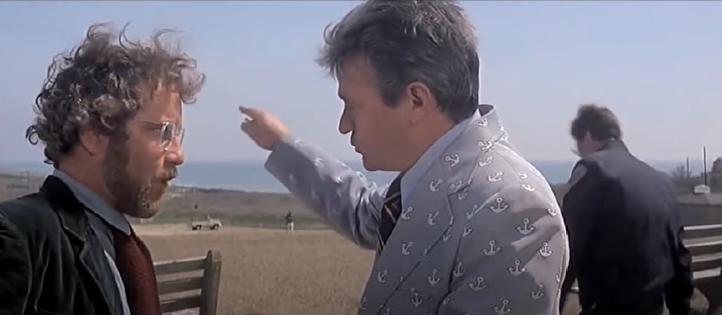
Hooper:
You have to ring this entire harbour with 100 gauge—
Vaughn: I don't think either one of you are familiar with our problems!
Hooper:
Uh, I think that I am familiar the fact that you are going to ignore this particular problem until it swims up and bites you in the ass! Now wait a second, wait a second!
Vaughn:
Chief? Hey Chief?
Hooper:
There are two ways to deal with this problem. You either gonna kill this animal or your gonna cut off its food supply.
Chief Martin Brody:
Larry we have to close the beaches.
Vaughn:
Brody? Sick vandalism. That is a deliberate mutilation of a public service message! Now I want those little paint-happy bastards caught and hung up by their Buster Browns!
Hooper:
That's it! Good-bye! I'm not going to waste my time arguing with a man who is lining up to be a hot lunch. I'm gonna see you later Brody.
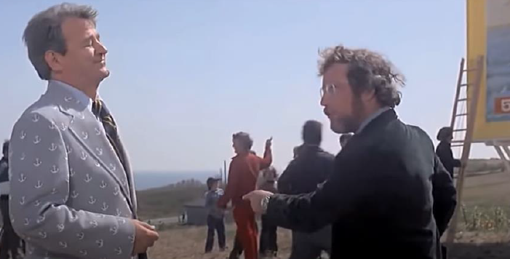

Chief Martin Brody:
Aw, now please don't do this, he's not...
Hooper:
Mr. Vaughn, what we are dealing with here is a perfect engine, ah, an eating machine. It's really a miracle of evolution. All this machine does is swim and eat and make little sharks. And that's all. Now why don't you take a long close look at this sign. Those proportions are correct.
Vaughn:
Love to prove that wouldn't ya? Get your name into the National Geographic!
Hooper:
Ha ha ha ha ha.

Chief Martin Brody:
Larry, Larry, if we make an effort today, we might be able to save August.
Vaughn:
August? Heh, for Christ's sake tomorrow is the fourth of July! And we will be open for business. It's gonna be one of the best summers we’ve ever had! Now if you fellas are concerned about the beaches, you do whatever you have to, to make them safe. But those beaches will be open for this weekend!
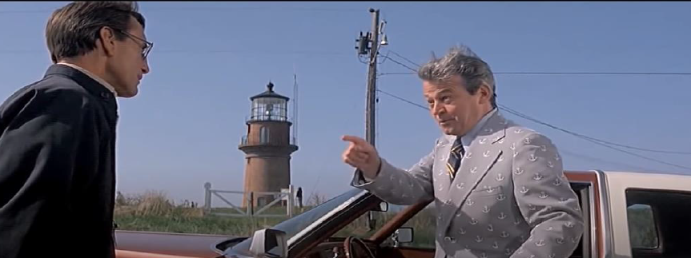

(Level 3 Communications – Non – Verbal and interpersonal communications)

Questions
1. What body language is used during the scene?
2. From watching the scene: What does their communication skills tell you about each character?
3. Why does the mayor want to keep the beaches open?
4. Hooper is an expert at what he does. Do you think the mayor respects his expert opinion? Give two examples to back up your view.
Comprehension questions (Level 2 -3)
a. Whose boat was all ‘chewed up’?
b. According to Hooper what was ‘correct’ about the drawing on the billboard?
c. According to the chief, along with closing the beach, what else would they have to do?
d. What happened in Jersey Beach in 1916?
e. What two ways does Hooper suggest to ‘deal with problem’?
Finish the sentences: Rewrite these sentences
1. What we are dealing with here is a perfect _ _ _ _ _ _.
2. There are two ways to deal with this _ _ _ _ _ _ _.
3. Look we depend on the summer people here for our _ _ _ _ _ _ _ _ _.
4. All this machine does is swim and eat and make _ _ _ _ _ _ _ _ _ _ _ _.
5. I'm not going to waste my time arguing with a man who is lining up to be a _ _ _ _ _ _ _ _.

