How Did Saloons in the Old West Lock Their Doors at Night?

We have all seen the films- John Wayne or Clint Eastwood walks through the saloon door.

That is 2 swinging half doors.
The question is – how did the saloons lock these doors at night? Did they leave them open? If they did what was to stop the cowboys walking in and drinking all the whiskey?
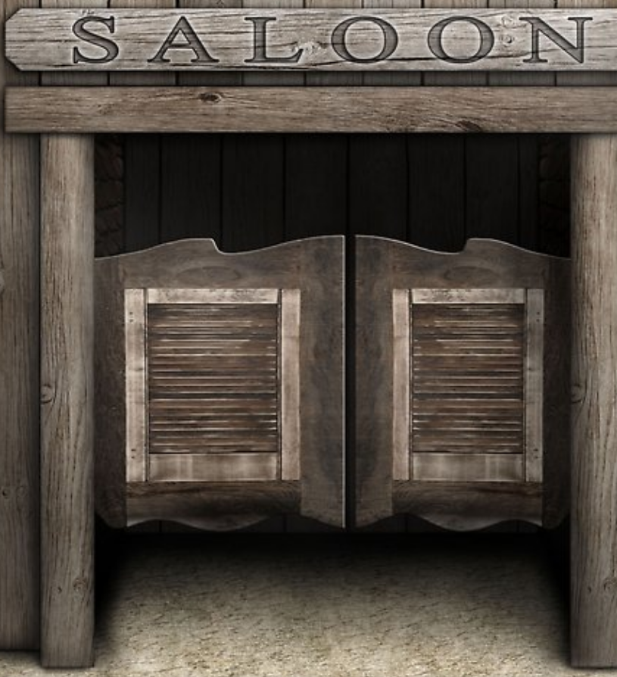
Why did they have doors like this in the first place. Well there were two reasons:
The first was the weather- it was often hot and humid in the wild west and the rooms were small. There was no air conditioning, so they had to let air in some way.
The second reason was the saddle. Cowboys could not leave their saddle on their horse when they went for whiskey – it would be stolen- so they had to carry it with them. As it’s hard to get through a door with a saddle they used the swinging door.
So how did they lock them at night?
Well the truth is there was usually another door outside the swinging doors – normal doors that swung shut over the swinging doors!

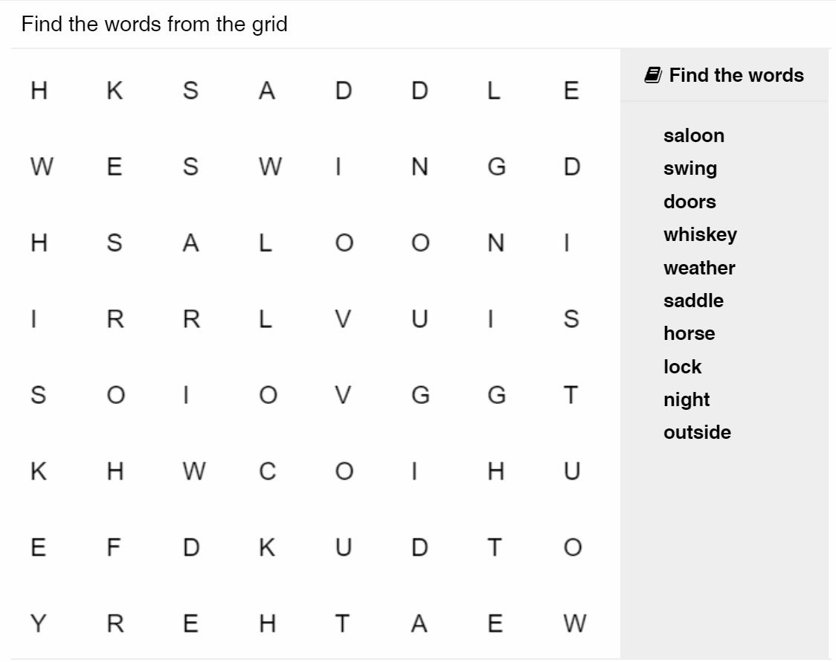
Write 3 or more sentences
Starting
The Cowboy walked into the bar…………………………..
________________________________________________________________________________________________________________________________________________________________________________________________________________________________________________________________________________________________________________________________________________________________________________________________________________________________________________________________
________________________________________________________________

